Saint Dunstan’s

Episcopal Church

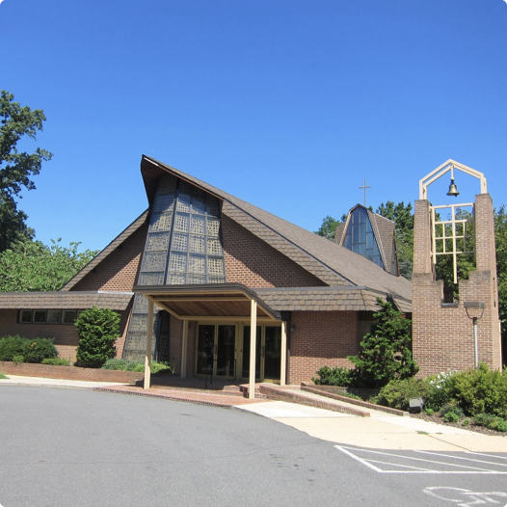
Parish Life
Welcome to St. Dunstan’s Episcopal Church
This booklet is designed for both members and newcomers. Our intent is to invite and encourage you to participate fully in the life of St. Dunstan’s Church. We hope that the descriptions of our activities and organizations will help you to know the parish better and will facilitate your involvement. The Church office can be contacted by phone at 703-356-7533 or email at office@stdunstans.net.
Clergy and Staff
The Reverend Stephen G. Shepherd, Rector
The Reverend Anna Scherer, Assistant Rector
Mr. Gray Snead, Christian Education Director
Mr. David B. Lang, Organist and Choirmaster
Barbara Everhart, Administrative Assistant
Vestry
Nancy Searby, Senior Warden
Jim Buttz and Peter Scanlon, Junior Wardens
Tony Griffin, Register
Tony Griffin, Dirk Suringa, Perry Williams, Group A (Finance, Stewardship, Communication)
Fred Vogel, Marilyn Hourican, Mike Cluff , Group B (Youth Christian Education, Adult Formation, Worship)
Martha Taishoff, Louisa Dietrich, Russ Keck, Group C (Fellowship, Outreach, Newcomers)
Worship Services
Sunday: 8:15 AM - Holy Eucharist (quiet)
10:15 AM - Holy Eucharist (music, nursery care)
1st and 3rd Sundays we offer the Ministry of Healing
Tuesday: 7:00 PM every 3rd Tuesday at Vinson Hall

Table of Contents
Worship Coming together to give our thanks and praise to God. Pages 4-6
(Acolytes, Altar Guild, Choir, Chalicers, Healing Ministers, Lectors, Oblationers, Ushers, Memorial Garden, Pet Memorial Garden, St. Francis Chapel, Vinson Hall)
Education Christian Formation for all ages. Pages 7-9
(Adult Forum, Bible Study, Spiritual Direction, Shrine Mont, Nursery, Sunday School and Children’s Chapel, Rite 13, Confirmation Class, Youth Group)
Outreach Serving the wider community. Pages 10-11
(Share of McLean, Lamb Center, Ronald McDonald House, Visitation Committee, Outreach Committee)
Fellowship Gathering together to share experiences and build relationships. Pages 12-14
(Bookworms, Dance Fitness, Lunch Bunch, Coffee Hour, Trivia Night, Shrine Mont, Youth Group, Women of St. Dunstan’s)
Stewardship Using the gifts God gives us to do the work God calls us to do. Pages 15-16
(Vestry, Senior Warden, Junior Wardens, Building and Grounds Committee, Treasurer)
Church Supported Groups Many organizations use our facilities during the week. Pages 17-18
(Brooksfield Montessori School, St. Francis Korean, Boy Scouts/Scouts BSA, Girl Scouts, McLean Youth Orchestra, Musikfest Ensemble)
Worship
Coming together to give our thanks and praise to God.

Acolytes
These are dedicated church members, 7th grade or older, who assist the clergy in the conduct of worship services as crucifers, torchbearers, and banner-bearers. Training is provided. Contact: Catherine Beauchamp.

Altar Guild
The Altar Guild prepares the sanctuary and chapel for worship services, weddings, and funerals. Duties include setup before services, cleanup after services, as well as maintenance of silver, brass, and altar linens. St. Dunstan’s currently has three teams who rotate on a weekly basis. New members are always welcome to join this vital ministry. Training is provided, no previous experience is needed. Contact: Pat Moore.

Choir
The choir helps lead the congregation in worship at the 10:15 A.M. service each Sunday from September to June. On occasion, choirs from multiple churches join together for a special worship service. Rehearsals are Thursday evenings and Sunday mornings. A contingent of choir members help lead the whole year, including summer, though the entire choir is usually only present through June. Contact: David Lang.

Chalicers
A lay person who assists the clergy during worship by distributing the Chalice (cup of wine) during Communion. Contact: Rev. Stephen Shepherd or Rev. Anna Scherer.

Healing Ministers
A lay person trained to offer prayers on behalf of those desiring healing for themselves and for others. Healing Ministry is offered on the first and third Sundays of each month. Contact: Rev. Stephen Shepherd or Rev. Anna Scherer.

Lectors
A lay person trained in reading scripture and the Prayers of the People during worship services. Contact: Rev. Stephen Shepherd or Rev. Anna Scherer.

Oblationers
These parishioners present the elements (the bread and wine) at the altar after the offering. Contact: Rev. Stephen Shepherd or Rev. Anna Scherer.

Ushers
These parishioners distribute service programs before the service; set up the sound system and distribute hearing aids, help find seats when the church is crowded; take up the offering; assist communicants returning from the altar rail; and inform clergy when someone needs communion and/or healing in the pews. Contact: Rev. Stephen Shepherd or Rev. Anna Scherer.

Memorial Garden
This wooded area is where the ashes of many parishioners and friends are interred. A bronze plaque with the names of all who are buried in this garden is found inside the church. This garden is open to the public, and provides a peaceful environment for contemplation and prayer.

Pet Memorial Garden
This wooded area to the left of the St. Francis Chapel is where the ashes of pets can be interred.

St. Francis Chapel
Our outdoor chapel, located near the woods and our memorial gardens. Every October, a Blessing of the Animals is held at this chapel.

Vinson Hall
Vinson Hall is a retirement community just a few blocks from St. Dunstan’s. Some of the residents there are parishioners or Episcopalians from other churches. Our clergy go to Vinson Hall once a month to lead a Eucharist service in their chapel. This is held on the third Tuesday of every month at 7:00 PM. Parishioners are welcome to participate by being a lector, or chalicer, or setting up before the service. Contact: Ann Dietrich.

Education
Christian Formation for all ages.
Adult Education

Adult Forum
Throughout the year, there are adult education programs that meet after both the 8:15 am and 10:15 am Sunday Services. Previous topics have included a Lenten Series on forgiveness, The Good Book Club (reading an entire book of scripture), and a series on The Way of Love.

Bible Study
There are currently three Bible study groups. One meets at church, on Wednesday mornings at 10:30 AM in the conference room next to the church office. Two meet off site, one Thursday evenings, and the other a group for mothers. Contact: church office.

Spiritual Direction
Also known as “spiritual companionship,” a Shalem Institute for Spiritual Direction trained spiritual director is available to journey with you as you deepen your relationship with God. Contact: Maureen Jenkins or church office.

Shrine Mont
A parish retreat is held every year at the beautiful Episcopal Retreat Center in Orkney Springs. This takes place on the fourth weekend in September. The focus for the adult program in 2019 was “Finding the Gospel in Turbulent Times.”
Youth Education

Nursery
Infant and childcare provided during the 10:15 AM Sunday service and at other announced times for special events. Contact: Gray Snead.

Sunday School and Children’s Chapel
Sunday school has offerings for children as young as Age 2, Pre-Kindergarten and Kindergarten, and Grades 1-6. At 10 AM children participate in an age-appropriate Worship service in the Parish Hall followed by Church School. Children later join their families in Church at the Peace before the Eucharist. Contact: Gray Snead.

Rite 13
Youth Spiritual formation, grades 7-8. The class name comes from a liturgical rite of passage we celebrate with the young people around their 13th birthday. During these two years, the community celebrates the amazing creative power and potential of these young people, and creates a safe haven in which to explore new ideas, new interests and new abilities. Contact: Gray Snead.

Confirmation Class
Youth Spiritual formation, grades 9-10. The class helps teens create and understand the importance of Christian community as they develop critical thinking and other skills they will need in adulthood. Teens learn different methods of Scripture reading, prayer and community-building. After two years, they are acknowledged as being equipped for new levels of responsibility and are given an opportunity to be confirmed in the Church. Questions, interest in confirmation, or serving as an adult mentor for teens, please contact: Rev. Stephen Shepherd.

Youth Group
Youth group for High School students, grades 9-12, offering teens opportunities to share their faith through fellowship and community service. It is a youth led organization that meets after the 10:15 AM service and plans monthly fellowship activities. Challenged to become good stewards of their time, talent and treasure, the group focuses on identifying their gifts and commit to a specific ministry that uses those gifts within the Church or the wider community. Questions, or interest in leadership support, Contact: Fred Vogel.

Shrine Mont
A parish retreat is held every year at the beautiful Episcopal Retreat Center in Orkney Springs. This takes place on the fourth weekend in September. There is nursery care for the youngest children, and specific activities appropriate for children all ages. Contact: Gray Snead.

Outreach
Serving the wider community.

Share of McLean
Share is a multifaceted organization that helps meet emergency needs in our local community, especially for food. A coalition of local religious and civic institutions (including St. Dunstan’s) founded Share in 1969. We support Share year-round. People can leave donations of non-perishable food and toiletries in baskets inside our church doors. Food cards and financial donations are also accepted, and can be placed in an envelope and put in the offering place or taken to the church office. Our main food drive is called “Thanksgiving in July.”

Lamb Center
The Lamb Center is a non-profit organization working to serve the poor and homeless, transform lives, and share God’s love. Once a month, parishioners or clergy from St. Dunstan’s go to the Lamb Center to lead a bible study for the clients and staff. This takes place on the first Wednesday of every month at 1:30 PM. Contact: Linda Young, Lucy Griffin, or Rev. Anna Scherer.

Ronald McDonald House
The Ronald McDonald House is a “home-away-from-home” for families so they can stay close by their hospitalized child at little or no cost. A home cooked meal is served every day to the residents. At St. Dunstan’s, a group of volunteers go every second Wednesday at 4:00 PM to bring food and prepare dinner.

Visitation Committee
A group of parishioners who visit shut-ins in their homes, providing fellowship and a connection to the St. Dunstan’s family. Training is provided. Other parishioners mail bulletins and cards to those unable to come to church. Contact: Rev. Stephen Shepherd or Rev. Anna Scherer.

Outreach Committee
The Outreach Committee meets four times a year to plan outreach activities for the year. The organizations that St. Dunstan’s has been involved with include: Share of McLean, Falls Church - McLean Children’s Center, the Lamb Center, Second Story, Ronald McDonald House, Samaritan Ministry of Greater Washington, Carpenter’s Kids, and Episcopal Relief and Development. Contact: Rev. Anna Scherer.

Fellowship
Gathering together to share experiences and build relationships.

Bookworms
An informational book discussion group that is open to all. The books are chosen by the group, and include a wide variety of themes. Bookworms meet on the second Saturday of each month at 10:30 AM in the conference room next to the church office. Contact: Helen Vogel.

Dance Fitness
This is a fitness session focused on keeping one’s body moving, held each Monday evening from 7:00 to 8:00 PM. All fitness levels are welcome to this drop in session, and the cost is a minimal $5.00 per session. Dance Fitness is facilitated by Dr. Sherry B. Scott, a health and wellness consultant, author, teacher, songwriter, and musician. Contact: Linda Young.

Lunch Bunch
A group of parishioners and friends who meet on the second Wednesday of the month at noon for lunch at a local restaurant. A carpool leaves the Church parking lot at 11:45 AM. Contact: Helen Vogel.

Coffee Hour
After the 10:15 AM service, a time of fellowship and welcome is offered. The coffee and refreshment table is hosted each week by various volunteers.

Trivia Night
This is a event scheduled at various times throughout the year. Pizza is served at 6:30 PM and the games begin at 7:00 for teens and adults. Questions are designed for multiple generations. Contact: Rev. Stephen Shepherd, Tami Shepherd.

Shrine Mont
A parish retreat is held every year at the beautiful Episcopal Retreat Center in Orkney Springs. This takes place on the fourth weekend in September. It is a time for fun, food, and fellowship for both the spirit and the body. Programs and activities are appropriate for all ages.

Youth Group
The Youth group is for High School students (9th-12th grade) looking to share their faith through fellowship and community service. It is a youth led organization that meets after the 10:15 AM service and plans monthly fellowship activities. Most of the community service is focused on assisting the elderly parishioners but the group also does other outreach activities. Contact: Fred Vogel.

Women of St. Dunstan’s
All women of St. Dunstan’s church are members of the Episcopal Church Women. Each year, a varied program is developed based on the expressed needs and interest of the women at St. Dunstan’s and includes companionship and mutual support, spiritual growth, intellectual stimulation and exploration of women’s issues. Activities sponsored by the Women of St. Dunstan’s include: support of the Falls Church - McLean Children’s Center, weekly mailings of the Sunday Bulletins to those parishioners unable to attend the regular Sunday service, the annual Holiday Craft Fair and other fundraisers to support the Children’s Center’s healthy snack program, the United Thank Offering, and the creation of this Parish Life Pamphlet. Contact: Elizabeth Lee.

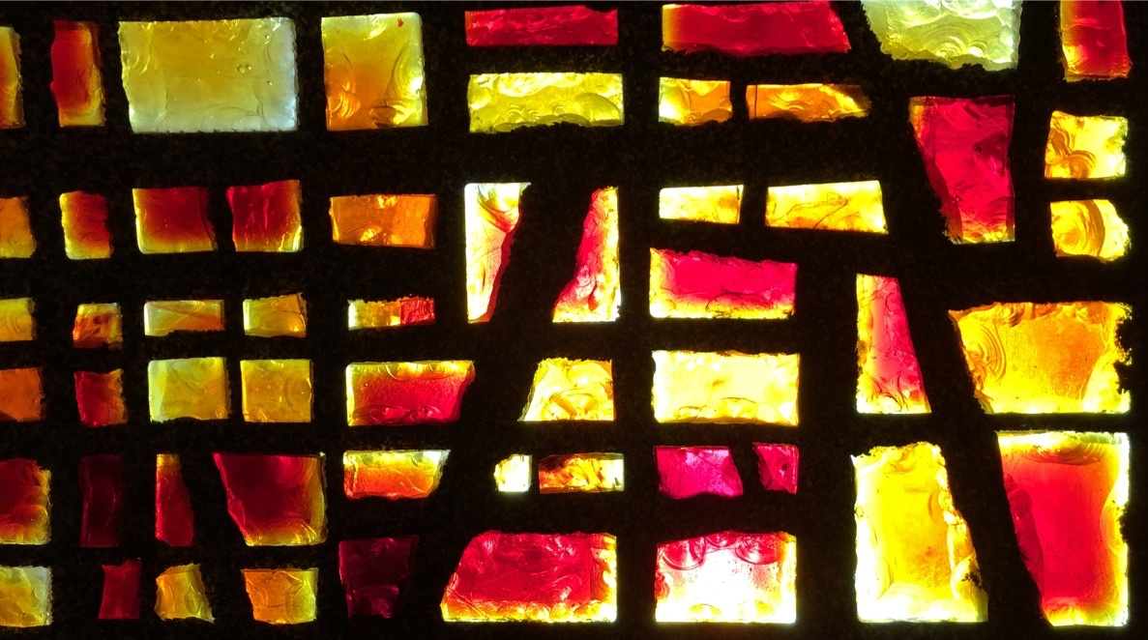
Stewardship
Using the gifts God gives us to do the work God calls us to do.

Vestry
The basic responsibilities of the vestry are to help define and articulate the mission of the congregation; to support the church's mission by word and deed, to select the rector, to ensure effective organization and planning, and to manage resources and finances. The vestry is the legal representative of the parish with regard to all matters pertaining to its corporate property. The Vestry also serves as an advisory council to the Rector who, by church law, is the parish's chief liturgical and pastoral officer. Vestry members are usually elected at the annual parish meeting. Wardens are selected from within the vestry, and are called "senior" and "junior."

Senior Warden
The senior warden is the primary elected lay leader of the congregation, and serves as a principal liaison between the parish and the rector. Wardens are the lay partners of the Rector in articulating the mission and vision of the parish, managing its day-to-day operations, identifying and nurturing leaders, and empowering members of the congregation to live out the Gospel in their daily lives. The senior warden can preside at vestry meetings.

Junior Wardens
The two junior wardens have been given responsibility for the upkeep of the parish buildings and grounds. Wardens are the lay partners of the Rector in articulating the mission and vision of the parish, managing its day-to-day operations, identifying and nurturing leaders, and empowering members of the congregation to live out the Gospel in their daily lives. A junior warden presides at vestry meetings if both the rector and the senior warden are absent.

Building and Grounds Committee
This is a committee formed of vestry members and parishioners who are interested in the maintenance of our church property. They organize and lead the Spring and Fall Parish Clean-ups, when parishioners and scouts spend a Saturday cleaning and maintaining church grounds. Contact: Junior Wardens.

Treasurer
The treasurer, who may or may not be a vestry member, maintains the financial and business records of the parish, prepares quarterly financial reports for the vestry, and prepares annual financial reports.

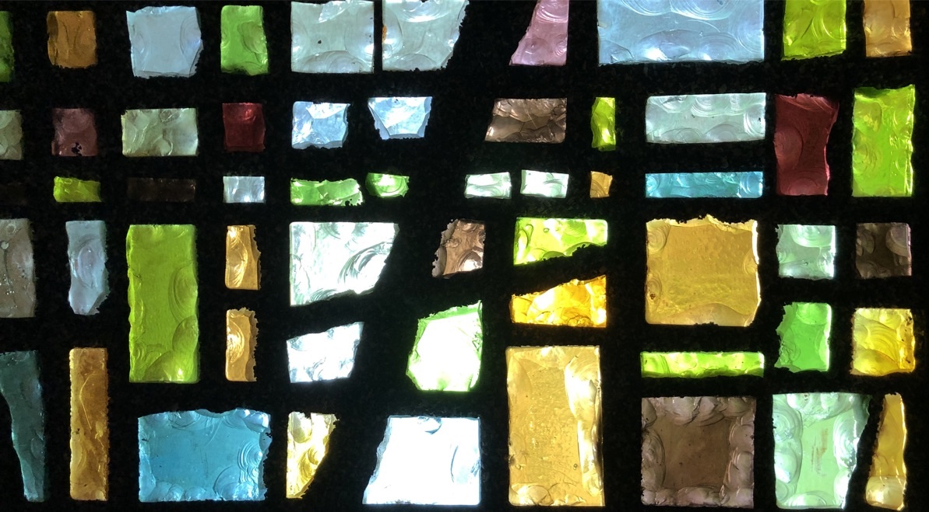
Church Supported Groups
Many organizations use our facilities during the week.

Saint Francis Korean
For many years, a Korean Episcopal congregation has shared the sanctuary and undercroft space for their services and events. Contact: Rev. Young Choi

Boy Scouts/Scouts BSA
Scouting is adventure, family, fun, character building, learning, leadership and so much more. Scouts learn the value of hard work and experience the thrill of seeing it pay off. Scouting is fun with a purpose by preparing young people to make ethical and moral choices over their lifetimes by instilling in them the values of the Scout Oath and Law. St. Dunstan’s is the Charter Organization for Venture Crew 652 (co-ed, ages 14-20), Boy Scout Troop 652 (co-ed, ages 11-17), and Cub Scout Pack 1867 (co-ed, grades K-5). Contact: Len Ward.

Girl Scouts
Girl Scouts offers the best leadership development experience for girls in the world. Girl Scouts takes the potential of girls, combines it with robust skill-building programming, and adds caring adult mentors and strong female role models. Everything a Girl Scout does centers around STEM, the outdoors, development of life skills, and entrepreneurship, and is designed to meet her where she is now and to grow along with her. Currently, a Brownie Troop (grades 2-3) meets at the church.

McLean Youth Orchestra
Founded in 1983, the McLean Youth Orchestra (MYO) is a project of the Tysons McLean Orchestra, a professional orchestra serving the Northern Virginia region. MYO was created to provide the finest possible musical education to students who represent the future of classical music in the community.

Musikfest Ensemble
A chamber orchestra and ensemble for youth, Musikfest Ensemble provides the finest musical educational programs in the Northern Virginia area. Musikfest is designed for committed string and wind players ages 12-18 years old.

Brooksfield Montessori School
For over five decades, Brooksfield School has shared space with St. Dunstan’s providing a nurturing and enriching early learning environment. Please call the school for additional information.

